Supplementary information, Gawel et al. RSOS 17051

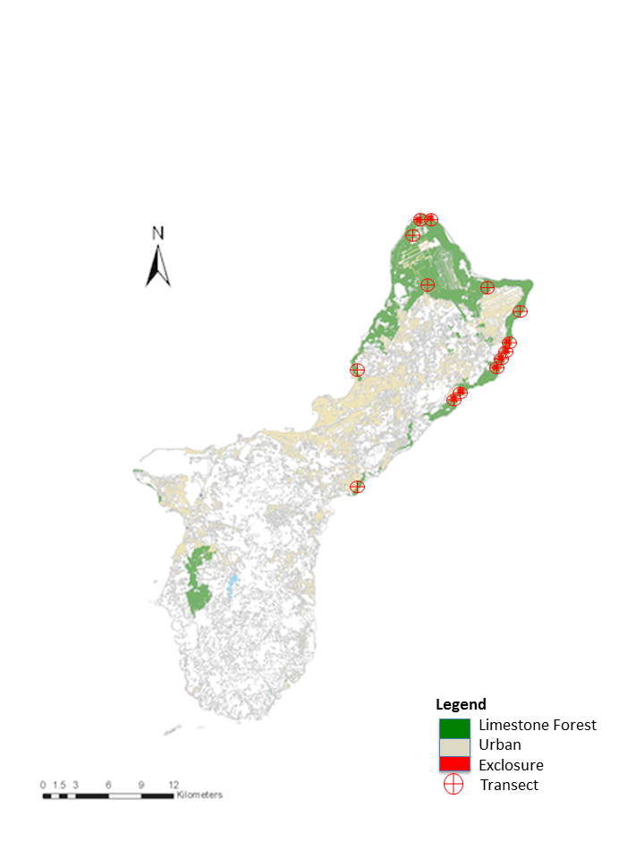

Supplementary Figure 1. Location of eight exclosures and 14 transects in Guam’s limestone karst forests.

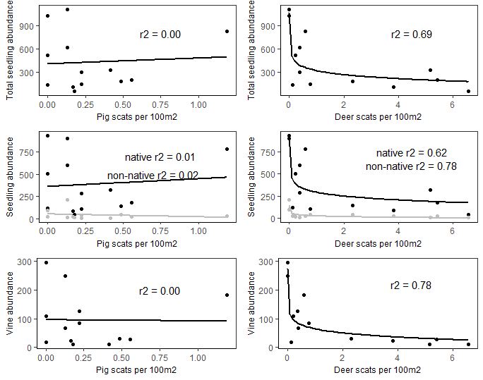

Supplementary Figure 2. Results from vegetation and scat surveys dropping “Tartop” site that had highest Deer scats per 100m2 value. Although scale of the x-axis is slightly smaller in the right-hand panel, trends and r2 values are almost identical to original results (see Figure 4 in manuscript).